1. 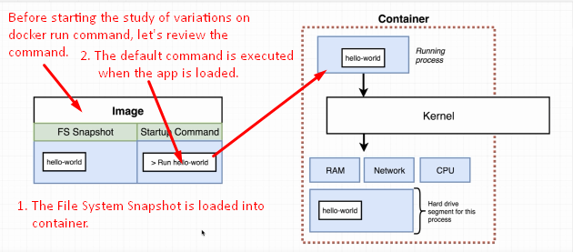
2. Let’s see how to override the default command execution when the app from the image is loaded into the container.
3. 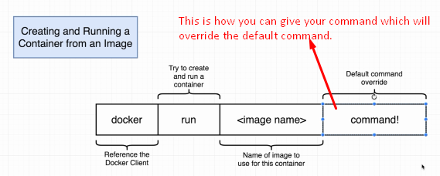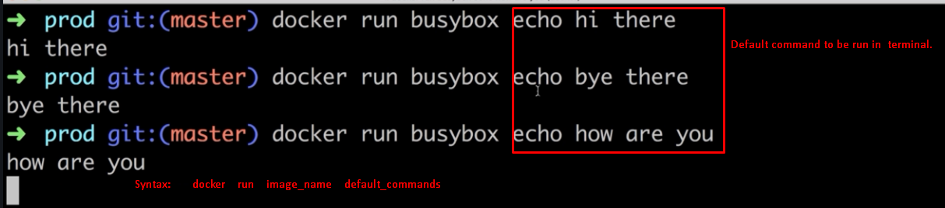
4. 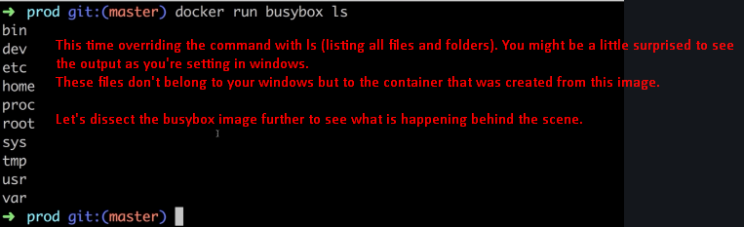
5. Let’s see what happens when we create a container out of image.
6. 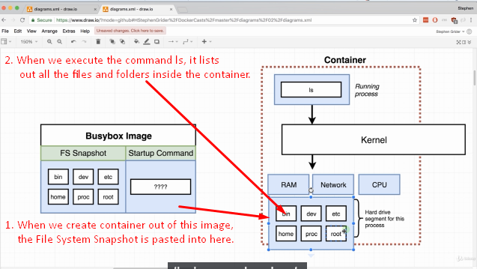
7. Now, the question why did we choose Busybox image here why not hello-world?
8. 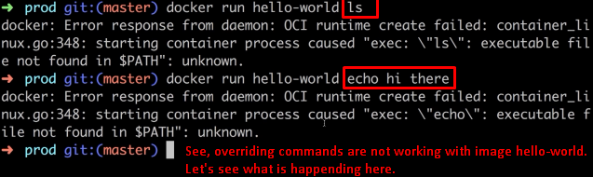
9. 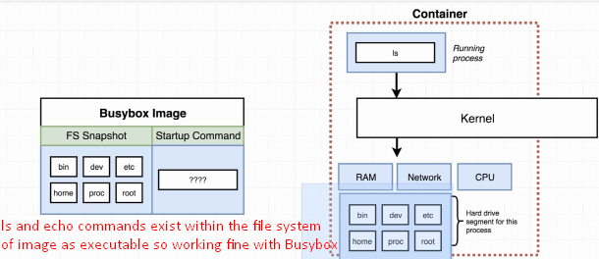
10. 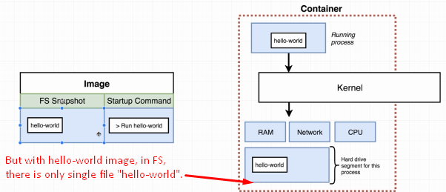
11. If we try to execute a command that is not contained inside the FS Snapshot (File System) as executable, we’re going to get an error.